8218-Arsh Nadeem-Introduction to Java 1-Jan-2025

1. Write a class with FirstName, LastName & age field. Print Firstname, LastName & age using static block, static method & static variable respectively.

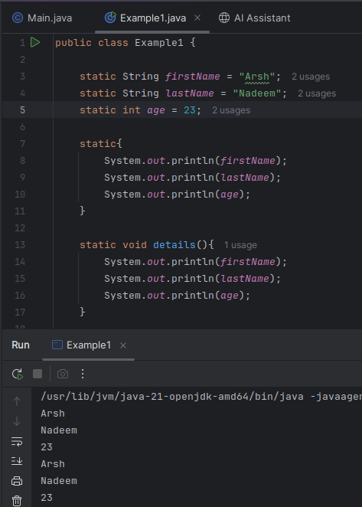

2. Write a program to read user input until the user writes XDONE and then show the entered text by the user on the command line.

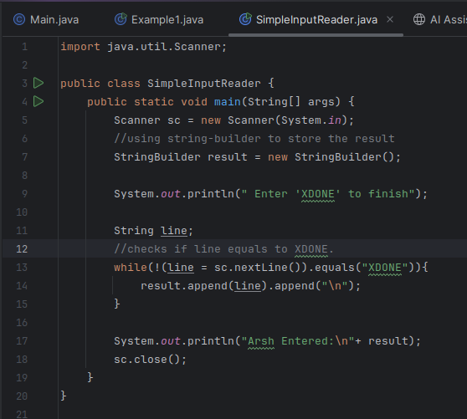

Output:
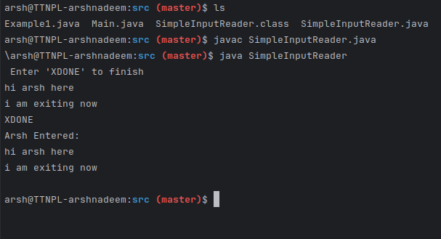

3. Write a java program to show following menu to the user:
i. Calculate Area of Circle
ii. Calculate Circumference of a Circle
iii. Exit. Choose an option (1-3): Take radius as user input.

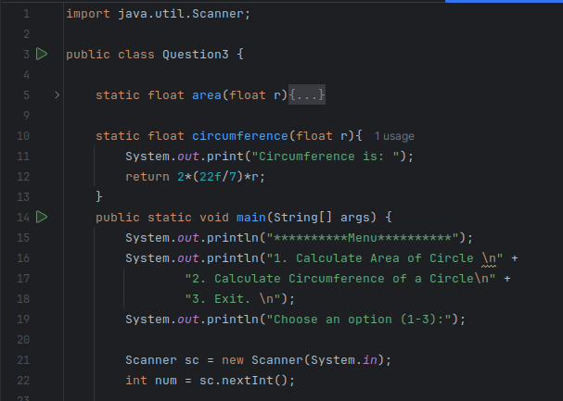
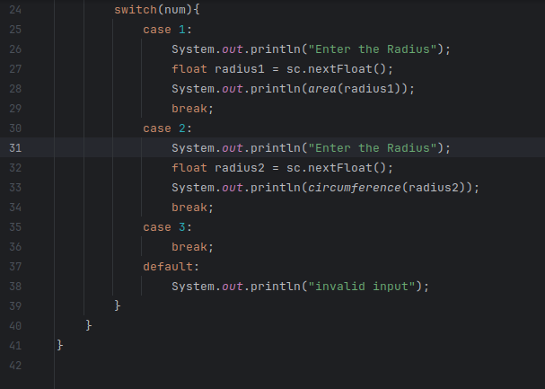

I have put the whole code in main in a while true box to test multiple cases to get the multiple output.
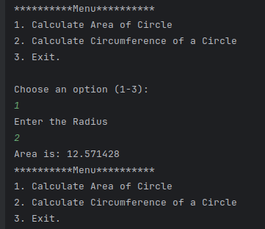

4. Create a two dimensional array of integers and display:
i. sum of all elements of each column
ii. sum of all elements of each row

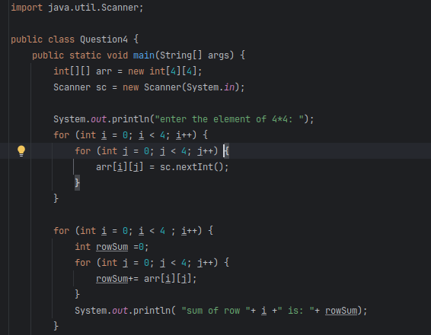

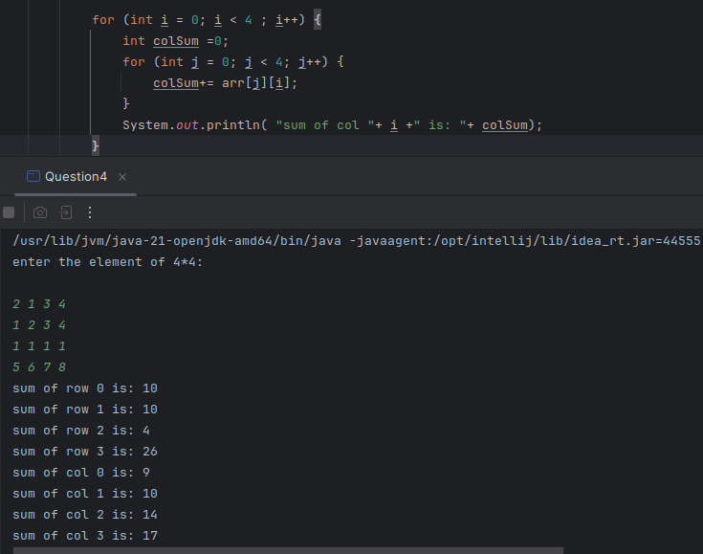

5. Create a class named Employee with fields firstname,lastname,age and designation. The class should:
i. have all types of constructors to initialize the object
ii. class should also have setter methods to update a particular field
iii. Override its toString method to display a meaningful message using all these fields.

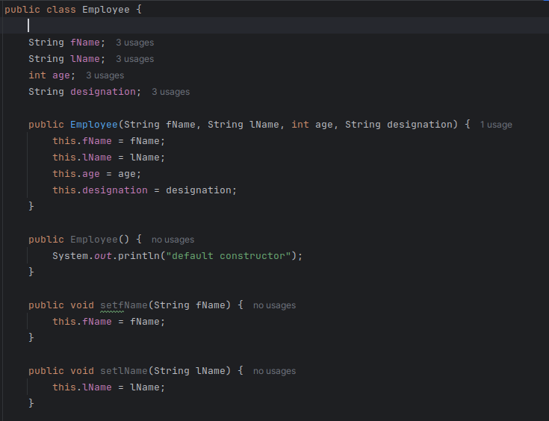
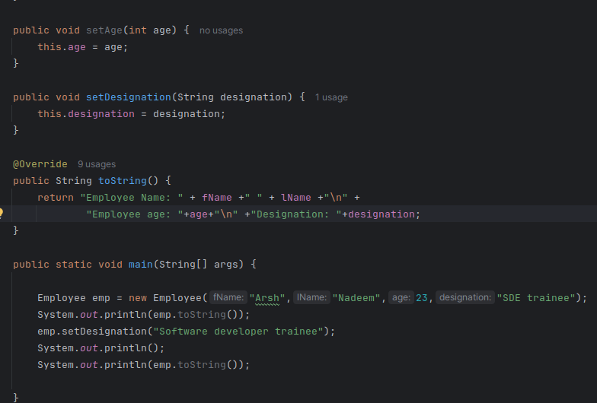
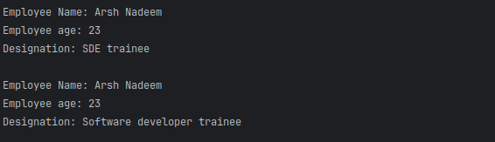
6. Implement a banking system using java. Create 3 sub class of Bank : SBI, BOI, ICICI Classes should have attributes like Name, headofficeAddress, chairmanName, branchCount, fdInterestRate, personalLoanInterestRate, homeLoanInterestRate. All 3 should have following methods:
i. add getters and setters for the fields
ii. print details of every bank (override toString)

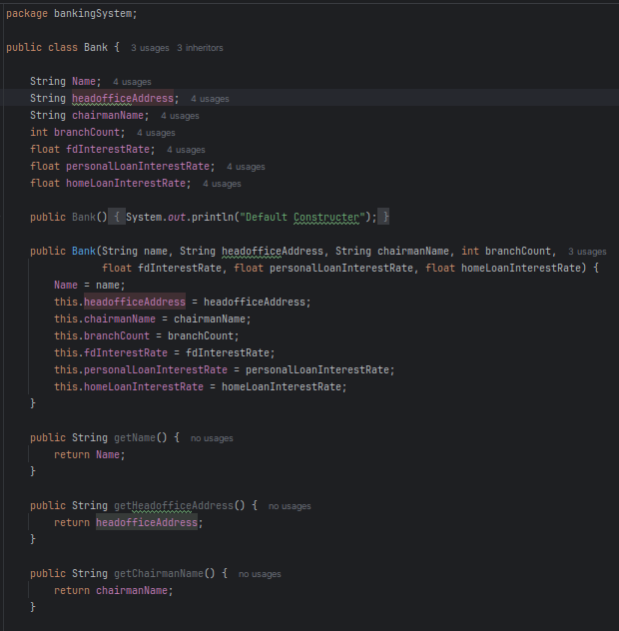

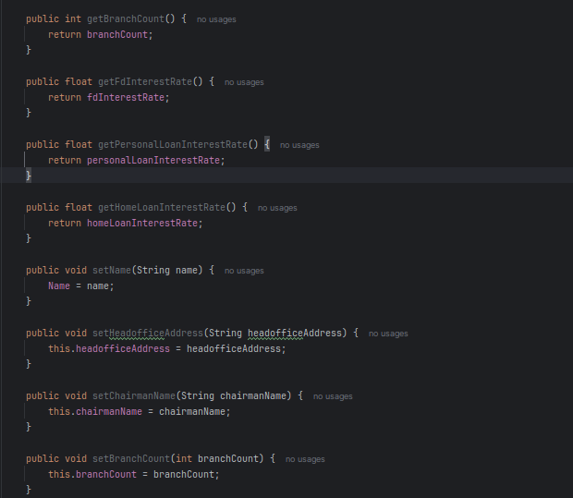

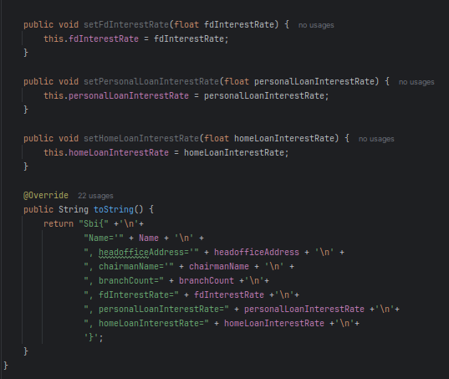

Now the subclasses with super reference to parent
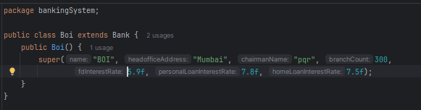
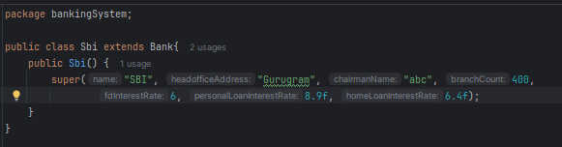
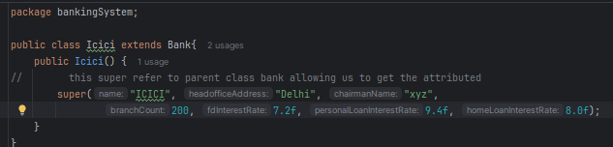

7. WAP showing try, multi-catch and finally blocks.

-> So in this program I used multiple catch boxes to catch different exceptions.
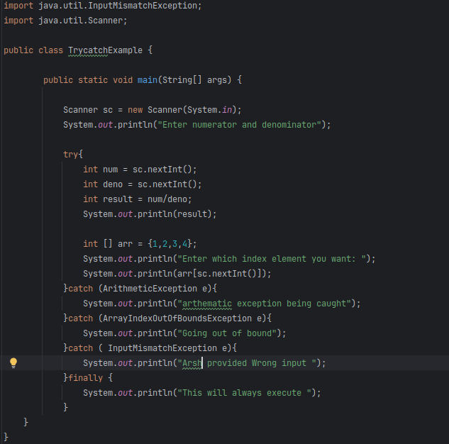

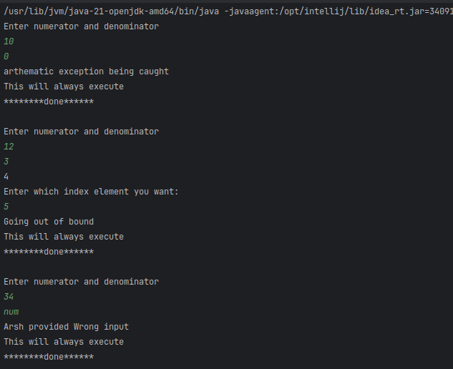

8. WAP to produce NoClassDefFoundError and ClassNotFoundException exceptions.

->Creating a missing class
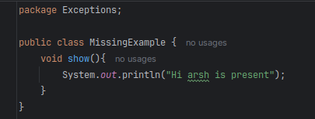

->in same package create main class
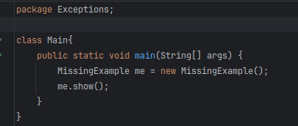

Now compile both using javac and delete ‘MissingExample’ using rm
Now run using java classname

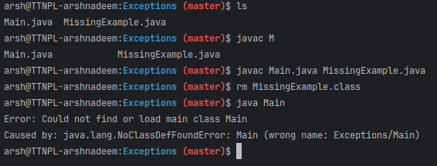

->class not found
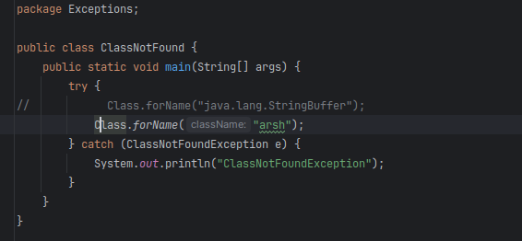
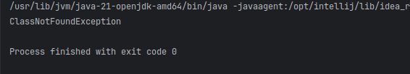

9. Create a custom exception that does not have any stack trace.

-> firstly i created a custom exception class to perform the operation
-> then i created my own custom exception class
-> to avoid stacktrace, i have to override a fillInstackTracemethod
And point it to the current message.

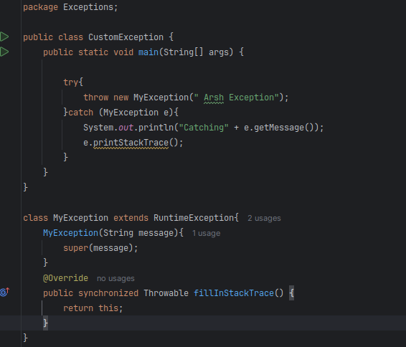

Output:
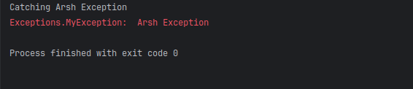
Output when I don’t override ‘fillInStackTrace()’:
